**PART II: NETWORK**

1. **Event calendar: Browse upcoming Relay chain events.**

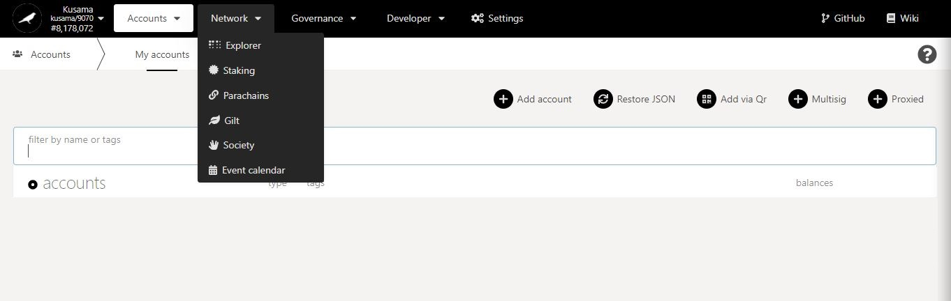

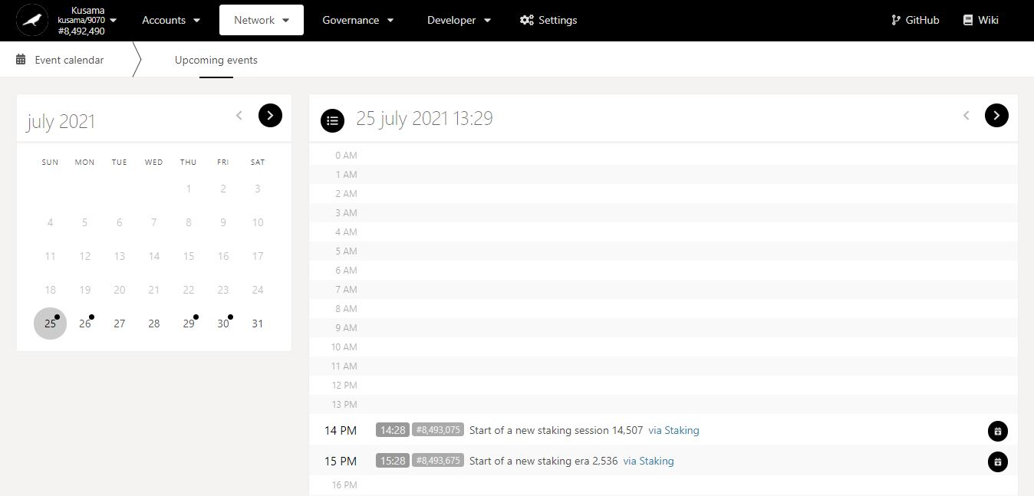

1. Click on a **day** to view its events.

Key information on upcoming events: **date, time, block number, description, and module.**

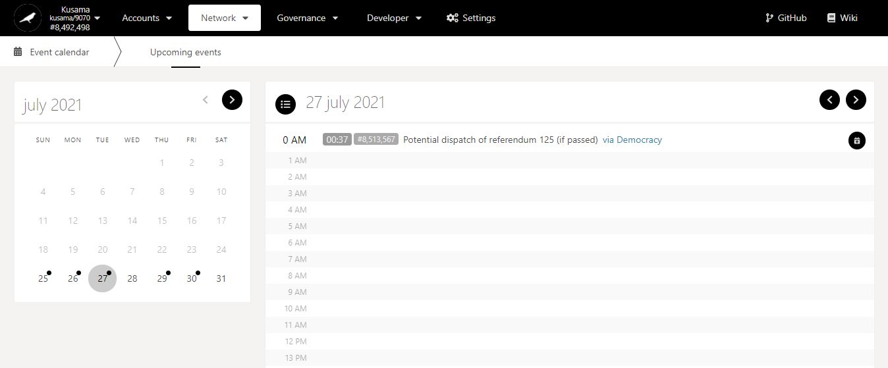

2. Click on the **module** to switch view on *Polkadot-JS Apps*.